January 2023

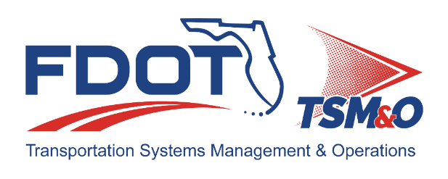

Florida ITS Architecture Support and Maintenance Project
2022-2023 Final District 2 Update Report
Version 1.0

Document Version Control
Author / Action | Submittal Date | Version No.
Arobindu Das / Draft Document | December 12, 2022 | 1.0
Cliff Heise / QA/QC Review | December 12, 2022 | 1.0
Cliff Heise / Final Document | January 31, 2023 | 1.0

Table of Contents
1.0 Introduction 4
2.0 Description of Changes 4

List of Tables
Table 1 ARCHITECTURE Updates 5
Table 2 Architecture Maintenance Log (District 2 RITSA) 7

Introduction
This Update Report for the Florida District 2 Regional ITS Architecture (RITSA) identifies the revisions incorporated into the architecture. The purpose of this District 2 RITSA Update Report is to document revisions made to the District 2 RITSA to support Stakeholder input received through Architecture Change Requests as part of the Florida Intelligent Transportation Systems (ITS) Architecture Support and Maintenance Project.
The Florida ITS Architecture Support and Maintenance Project included the initial major update of the Statewide ITS Architecture (SITSA) and seven RITSAs. Following the major update phase, periodic updates are executed to maintain the architecture content. The FDOT Architecture Team coordinates with the FDOT Project Manager or designee and each applicable District Transportation Systems Management and Operations (TSM&O) Program Engineer or designee for the RITSAs.

Description of Changes
One maintenance log items was addressed in the update. Table 1 provides descriptions for each change request that was implemented in the architecture update. A log reference number is provided for each change to related it to the Architecture Maintenance Log that is provided in Appendix A. Each architecture change that is received is added to the maintenance log for tracking and disposition.
Information about stakeholders, elements, and services is provided to summarize the changes. Some architecture components such as interfaces, roles and responsibilities, functional requirements and standards are numerous and can be reviewed on the architecture website or in the Regional Architecture Development for Intelligent Transportation (RAD-IT) software tool to explore the details of each project.

Table 1 ARCHITECTURE Updates
Change | Log Ref # | Actions Taken / Changes Implemented
Add Railroad Advanced Notification System Project: District 2 intends to apply new detection technology (comprehensive CCTV analytics), edge devices, advanced messaging (static sign with flashing beacon or embedded DMS), in conjunction with SunGuide alert capabilities via FL511 and WAZE. The intent of the system is to also capture data on the number of rail cars, speed and travel time throughout the municipality. Additional information at https://www.fdot.gov/traffic/teo-divisions.shtm/cav-ml-stamp/cv/maplocations/railroad-advanced-notification-system | 136 | Added new project: Railroad Advanced Notification System Project  - Added Element: Train Cars representing freight train car.  - Updated Element: Updated description of the Private Sector Traveler Information Systems element.  - Added Services:  - TM01: Infrastructure-Based Traffic Surveillance (FDOT District 2 Railroad Advanced Notification System)  - TM14: Advanced Railroad Grade Crossing (FDOT District 2 Railroad Advanced Notification System)  - TM15: Railroad Operations Coordination (FDOT District 2 Railroad Advanced Notification System)  - Added Interfaces.  - Added Roles and Responsibilities.  - Added Functional Requirements.  - Selected Communications Solutions.

Appendix A: Architecture Maintenance Log (District 2 RITSA)
The maintenance log in Table 2 provides the District 2 RITSA maintenance items considerations for the update.

Table 2 Architecture Maintenance Log (District 2 RITSA)
# | Date | Architecture | Source | Contact | Change | Disposition | Recommend Maintenance | Incorporated
136 | 10/13/2022 | D2 RITSA | Change Request Form: FDOT District 2 | Pete Vega / FDOT | Railroad Advanced Notification System Project: District 2 intends to apply new detection technology (comprehensive CCTV analytics), edge devices, advanced messaging (static sign with flashing beacon or embedded DMS), in conjunction with SunGuide alert capabilities via FL511 and WAZE. The intent of the system is to also capture data on the number of rail cars, speed and travel time throughout the municipality. Additional information at https://www.fdot.gov/traffic/teo-divisions.shtm/cav-ml-stamp/cv/maplocations/railroad-advanced-notification-system | Add new project. | Yes | Yes

