August 2026

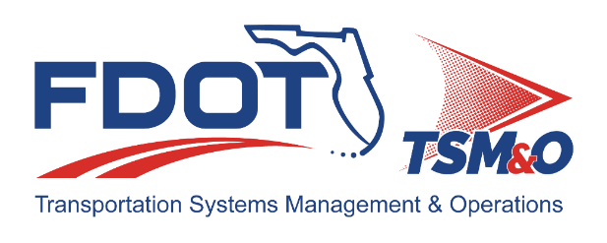
Florida ITS Architecture Support and Maintenance Project
D4-6 RITSA Update Report
(ARC-IT Version 9.4)

Document Version Control
Author / Action | Submittal Date | Version No.
David Binkley / Draft Document Development | August 17, 2026 | A94-2026
Cliff Heise / QA/QC Review | August 17, 2026 | A94-2026

Table of Contents
1.0 Introduction 4
2.0 Description of Changes 4

List of Tables
Table 1. Architecture Updates 4
Table 2. Architecture Maintenance Log (D4-6 RITSA) 7

Introduction
This Architecture Update Report for the Florida D4-6 Regional Intelligent Transportation Systems (ITS) Architecture (D4-6 RITSA) identifies the revisions incorporated into the architecture. Revisions made to the D4-6 RITSA are documented in this report to support Stakeholder input received through Architecture Change Requests as part of the Florida ITS Architecture Support and Maintenance Project.
The Florida ITS Architecture Support and Maintenance Project included the initial major update of the Statewide Regional ITS Architecture and seven Regional ITS Architectures. Following the major update phase, periodic updates are executed to maintain the architecture content. The FDOT Architecture Team coordinates with the FDOT Project Manager or designee and each applicable District Transportation Systems Management and Operations (TSM&O) Program Engineer or designee for the RITSAs.

Description of Changes
This update incorporates the conversion from RAD-IT 9.3 to 9.4 along with one maintenance log item. The period of accepting change requests is still open so any additional change requests for districts 4 and 6 will be incorporated at a later date. Table 1 provides descriptions for each change request that was implemented in this architecture update. A log reference number is provided for each change to relate it to the Architecture Maintenance Log that is provided in Appendix A. Each architecture change that is received is added to the maintenance log for tracking and disposition.
Information about stakeholders, elements, and services is provided to summarize the changes. Some architecture components such as interfaces, roles and responsibilities, functional requirements and standards are numerous and can be reviewed on the architecture website or in the Regional Architecture Development for Intelligent Transportation (RAD-IT) software tool to explore the details of each project.
Table 1. Architecture Updates
Change | Log Ref # | Actions Taken / Changes Implemented
Conversion | n/a | The D4-6 RITSA was converted to the latest version of the RAD-IT software, v9.4, that was released in July 2026.
Inventory element name change | 218 | Changed the name of the Palm Beach International Airport to the Donald J Trump International Airport. This change was reflected in the following places:  - Stakeholder description for the Palm Beach Airports Department  - Inventory element: Palm Beach International Airport now called the “Donald J Trump International Airport”  - Service packages diagrams,  - DM01 - ITS Data Warehouse (Regional ITS Data Warehouse (4 of 5))  - PT14 - Multi-modal Coordination (Palm Tran)  - MC08 - Maintenance and Construction Activity Coordination (FDOT District 4 (3 of 3))  - MC08 - Maintenance and Construction Activity Coordination (County and Municipal Maintenance (4 of 4))  - PT14 - Multi-modal Coordination (Local Transit Operators / Local TMA Transit Systems (1 of 2))  - Information flow diagrams

Appendix A: Architecture Maintenance Log (D4-6 RITSA)
The maintenance log in Table 2 provides the D4-6 RITSA maintenance items considerations for the update.
Table 2. Architecture Maintenance Log (D4-6 RITSA)
# | Date | Source | Contact | Change | Disposition | Recommend Maintenance | Incorporated
218 | 7/21/2026 | Change Request Form: FDOT District 4 | Alexandra Lopez / FDOT D4 | Change all references from PBI to DJT (including "Palm Beach International Airport") | Update Stakeholder, Inventory, and associated flow diagrams. | Yes | Yes

